
SRM Institute of Science and Technology
Mode of Exam
OFFLINE
College of Engineering and Technology
School of Computing
DEPARTMENT OF COMPUTATIONAL INTELLIGENCE
SRM Nagar, Kattankulathur – 603203, Chengalpattu District, Tamilnadu
Academic Year: 2024-2025 (ODD) SET - A
Test: CLAT-1 Date: 14.06.24
Course Code & Title: 18AIE424T- ARTIFICIAL INTELLIGENCE AND INTERNET OF THINGS
Duration: 50 minutes
Year & Sem: IV & VII Max. Marks: 25

Course Articulation Matrix:

S.No. | Course Outcome | PO1 | PO2 | PO3 | PO4 | PO5 | PO6 | PO7 | PO8 | PO9 | PO10 | PO11 | PO12
1 | CO1 | H | - | - | H | H | - | - | - | M | L | - | H
2 | CO2 | - | - | - | - | - | - | - | - | - | - | - | -
3 | CO3 | - | - | - | - | - | - | - | - | - | - | - | -
4 | CO4 | - | - | - | - | - | - | - | - | - | - | - | -
5 | CO5 | - | - | - | - | - | - | - | - | - | - | - | -

Part - A
( 5 x 1 = 5 Marks)
Instructions: Answer all
Q. No | Question | Marks | BL | CO | PO | PI Code
1 | Which of the following libraries can be used to read and write CSV files in Python?  - pandas  - hdf5  - matplotlib  - seaborn | 1 | 1 | 1 | 1,4 | 1.4.1
2 | HDF5 is particularly useful for storing:  - Small, text-based datasets  - Large, complex datasets with diverse data types  - Executable programs  - Simple key-value pairs | 1 | 1 | 1 | 1 | 1.4.1
3 | Which of the following is a characteristic of Big Data in the context of IoT?  - Volume, Velocity, Variety  - Veracity, Visibility, Verifiability  - Volume, Vision, Volatility  - Velocity, Value, Variance | 1 | 1 | 1 | 1 | 1.3.1
4 | The first step in the standard process of data mining is:  - Data cleaning  - Data collection  - Data analysis  - Data visualization | 1 | 1 | 1 | 1 | 1.3.1
5 | Keras is an API designed to run on top of which deep learning framework?  - PyTorch  - Caffe  - TensorFlow  - Theano | 1 | 1 | 1 | 1 | 1.3.1
Part – B
( 5 x 2 = 10 Marks)
Instructions: Answer any 2
6 | With the help of a diagram, explain the different layers of the IoT reference model and why are they important? | 5 | 1 | 1 | 1 | 2.1.1
7 | Explain the various services provided by AI/Iot platforms and detail the cloud platforms. | 5 | 2 | 1 | 1,5 | 2.1.1
8 | List out the steps in data mining and how are they used in IoT? | 5 | 1 | 1 | 1 | 2.1.1
PART – C
(10 x 1 =10 Marks)
Instructions: Answer any 1
9 | Explain how to read, save and process the data collected from IoT systems using different file formats. | 10 | 2 | 1 | 1,5 | 2.3.1
10 | With the help of an illustration, How can you use Tensor Flow and Keras to build a machine learning model for IoT data? | 10 | 3 | 1 | 1,4 | 2.3.1

*Performance Indicators are available separately for Computer Science and Engineering in AICTE examination reforms policy.

Course Outcome (CO) and Bloom’s level (BL) Coverage in Questions

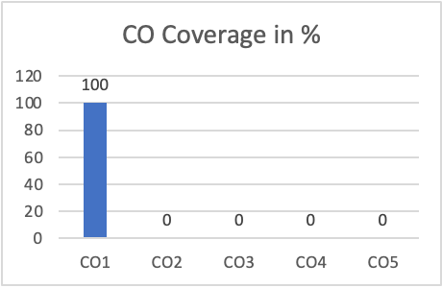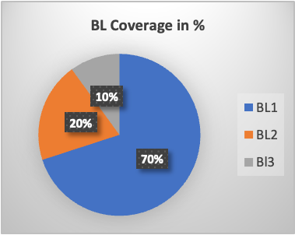
Approved by the Audit Professor/Course Coordinator

